1
#include <stdio.h>

void sort(int *x,int n)
{
int i,j,t;
for(i=0;i<n;i++)
for(j=0;j<n;j++)
if(x[i]<=x[j])
{t=x[i];
x[i]=x[j];
x[j]=t;}
for(i=0;i<n;i++)
printf("%d ",x[i]);
printf("\n");
}

main()
{
int a[100],i,n1;
printf("请输入数组大小:");
scanf("%d",&n1);
printf("请输入N个整数:");
for(i=0;i<n1;i++)
scanf("%d",&a[i]);
sort(a,n1);
}

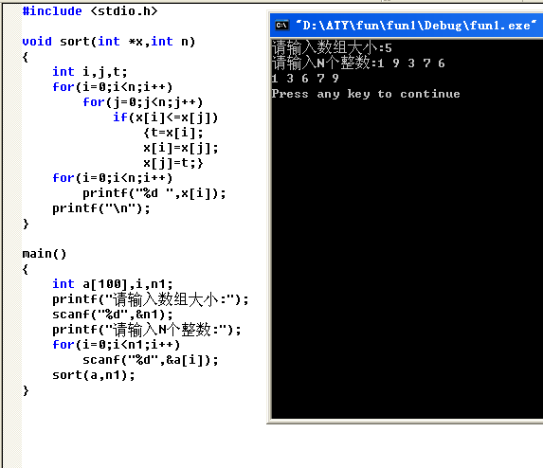

2_1
#include <stdio.h>
#include <string.h>

void replace(char*s,char c1,char c2)
{
int n,i,j,k;
printf("原字符串为:");
puts(s);
n=strlen(s);
for(i=0;i<n;i++)
if(s[i]==c1)
s[i]=c2;
printf("转换后的字符串为:");
puts(s);
}

main()
{
char s1[100],c11,c22;
int i;
printf("请输入字符串:");
gets(s1);
printf("请输入c1和c2(以空格隔开):");
scanf("%c %c",&c11,&c22);
replace(s1,c11,c22);
}

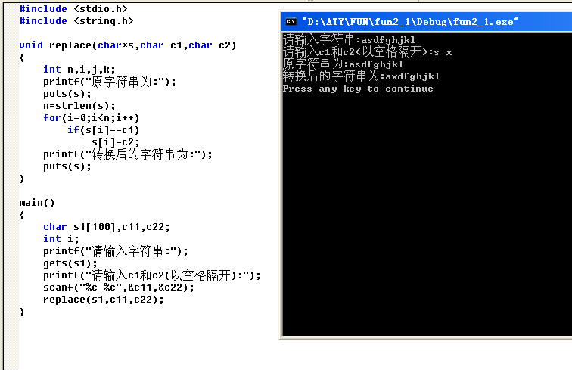
2_2

3
#include "time.h"
#include "stdlib.h"
#include "stdio.h"
void main()
{
char c;
clock_t start,end;
time_t a,b;
double var;
int i,guess;
srand(time(NULL));
printf("Do you want to play it.('y'or'n')\n");
loop:
while((c=getchar())=='y')
{
i=rand()%100;
printf("\nPlease input number you guess:\n");
start=clock();
a=time(NULL);
scanf("%d",&guess);
while(guess!=i)
{
if(guess>i)
{
printf("Please input a little smaller.\n");
scanf("%d",&guess);
}
else
{
printf("Please input a little bigger.\n");
scanf("%d",&guess);
}
}
end=clock();
b=time(NULL);
printf("\lIt took you %6.3f seconds.\n",var=(double)(end-start)/1000);
printf("\lIt took you %6.3f seconds.\n\n",difftime(b,a));
if(var<15)
printf("\l\lYou are very clever!\l\l\n\n");
else if(var<25)
printf("\l\lYou are normal!\l\l\n\n");
else
printf("\l\lYou are stupid!\l\l\n\n");
printf("\l\lCongradulations!\l\l\n\n");
printf("The number you guess is %d",i);
}
printf("\nDo you want to try it again?(\"y\".or.\"n\")\n");
if((c=getchar())=='y')
goto loop;
}

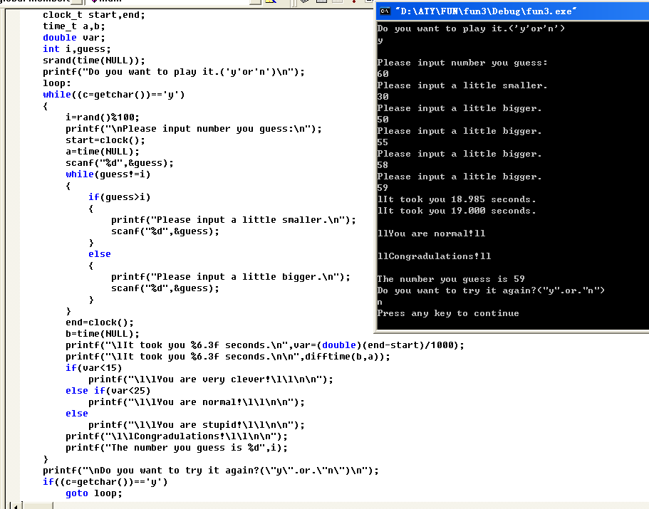
4
#include <stdio.h>

void doing()
{
char x[50]={'\0'};
int i;
printf("请输入五个字符:");
for(i=0;i<5;i++)
scanf("%c",&x[i]);
for(i=4;i>=0;i--)
printf("%c ",x[i]);
printf("\n");
}

main()
{
doing();
}

/*void doing(char x[])
{
int i=0;
if(x[i]!='\0')
{
doing(&x[i+1]);
printf("%c",&x[i]);
}
else return;
}

void main()
{char a[50];
gets(a);
doing(a);
}*/

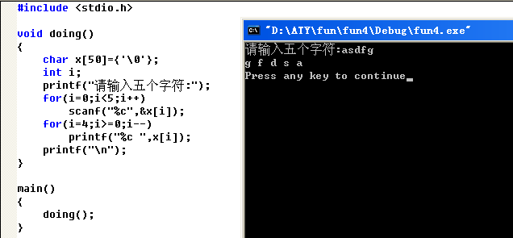

5
6

7
#include <stdio.h>

int a[20]={0};

void f1()
{
int i,j,t=0;
for(i=0;i<20;i++)
{
t=t+2;
a[i]=t;
}
for(i=0;i<4;i++)
{for(j=0;j<5;j++)
printf("%02d ",a[i*5+j]);
printf("\n");}
}

void f2()
{
int i,j,b2[4]={0};
for(i=0;i<4;i++)
{for(j=0;j<5;j++)
b2[i]=b2[i]+a[i*5+j];}
printf("平均值为:");
for(i=0;i<4;i++)
printf("%d ",b2[i]/5);
printf("\n");
}

void main()
{
f1();
f2();
}

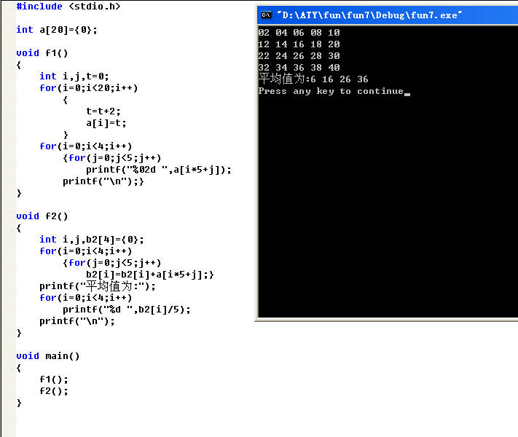

8

9
#include <stdio.h>
#include <math.h>
#include <string.h>

#define N 5
int per[N];

void input()
{
int i;
printf("请输入%d位同学的成绩:",N);
for(i=0;i<N;i++)
scanf("%d",&per[i]);
}

void count(int p[N])
{
int i,j;
char sym=37;
int q9=0,q8=0,q7=0,q6=0,q0=0;
float q=0;
for(i=0;i<N;i++)
{if(p[i]>=90&&p[i]<=100)
q9++;
else if(p[i]>=80&&p[i]<90)
q8++;
else if(p[i]>=70&&p[i]<80)
q7++;
else if(p[i]>=60&&p[i]<70)
q6++;
else if(p[i]>=0&&p[i]<60)
q0++;}
q=N-q0;
printf("0到60分的人数有:%d\n60到70分的人数有:%d\n70到80分的人数有:%d\n80到90分的人数有:%d\n90到100分的人数有:%d\n",q0,q6,q7,q8,q9);
printf("及格率为:%.2f%c\n",(q/N)*100,sym);
}

void avmaxmin(int pp[N])
{
int i,j,pl=0,av=0,max=0,min=100;
for(i=0;i<N;i++)
pl+=pp[i];
av=pl/N;
for(i=0;i<N;i++)
if(max<=pp[i])
max=pp[i];
for(i=0;i<N;i++)
if(min>=pp[i])
min=pp[i];
printf("平均分为:%d\n最高分为:%d\n最低分为:%d\n",av,max,min);
}

main()
{
input();
printf("%d %d %d %d %d\n",per[0],per[1],per[2],per[3],per[4]);
count(per);
avmaxmin(per);
}

